2025 Stack Overflow Developer Insights
The Career & Salary Roadmap
A Data-Driven Analysis of Global Tech Trends and Financial Growth
1. Executive Summary
This project analyzes the 2025 Stack Overflow Developer Survey (initially 49,191 responses) to identify high-growth career trajectories. By merging Python's data cleaning capabilities with PostgreSQL’s analytical power, I uncovered the "AI Premium," identified the true entry points for various tech stacks, and debunked common myths about junior-level roles in specialized fields.
2. The Data Journey
Data Auditing & Cleaning (Python/Pandas)
The raw dataset was massive (49k+ rows and 172 columns), requiring a rigorous cleaning pipeline:
- Salary Validation: Discovered that 50% of salary entries were null. I filtered these to focus on the 22,121 responses with valid compensation and tech-stack data.
- Outlier Removal: Used Quantile Filtering (0.05 to 0.95) to remove unrealistic data (like $1 salaries). The final analyzed salary range was $3,495 to $232,029.
- Data Normalization: Lowercased all columns for database compatibility and "exploded" the semi-colon-separated ‘language_have_worked’ column into individual rows to allow for granular SQL analysis.
The SQL Engine (PostgreSQL)
I moved the cleaned data into a PostgreSQL database using SQL Alchemy to perform complex relational queries:
- Relational View: Created a view called ‘final_career_roadmap’ that joins developer profiles with individual tech stacks.
- Window Functions: Utilized LAG() to calculate the exact "Salary Jump" for developers moving from Mid to Senior levels.
3. Key Strategic Insights
Based on the analysis, here are the four major findings for 2025:
Finding 1: The "AI Premium" is Real
Developers who professionally integrate AI agents into their workflow earn 16.3% more than those who do not. This confirms that AI skills are no longer optional but a financial advantage.
Finding 2: The Junior Entry-Point Myth
- Web Development remains the most accessible entry point for freshers, characterized by a lower median entry salary.
- Cloud & DevOps "Junior" roles actually have a much higher median pay ($29k), proving these are not typically "beginner" roles; companies hire people for these paths who already have a basic IT background.
Finding 3: The Salary Leaderboard (Top 5 Languages)
While languages like Python and JavaScript are the most popular, they do not pay the most. The top 5 paying languages in 2025 are:
- Elixir
- Ruby
- Perl
- Swift
- Groovy
Finding 4: Education vs. Experience
Using SQL, I mapped how Education Level (edlevel) correlates with growth. While a Master’s degree offers a higher starting point, specialized technical experience in "Enterprise & Systems" paths eventually bridges the gap in senior roles.
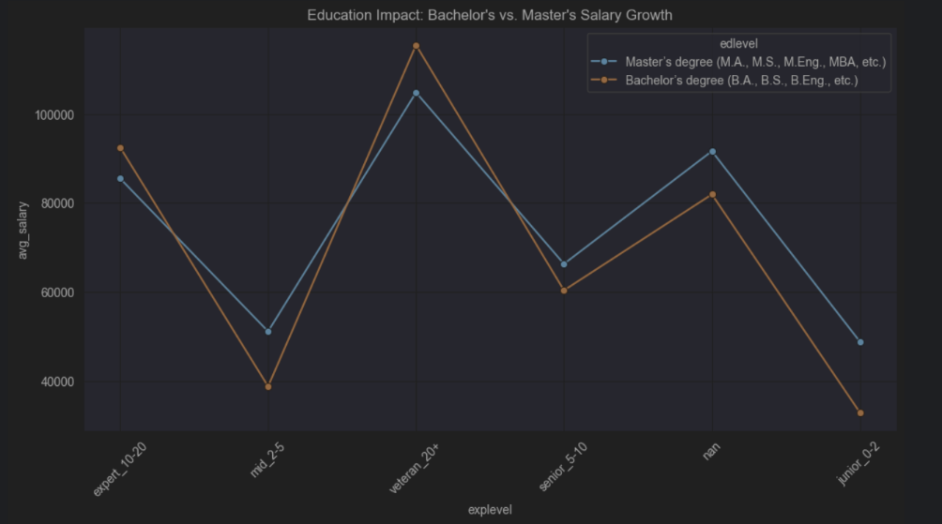
4. Visualizing the Roadmap
The following heatmap illustrates the salary progression across different technical paths as experience increases:
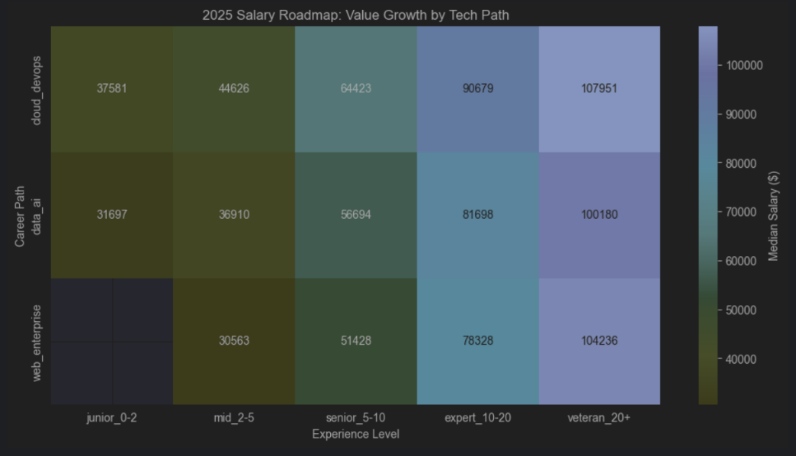
5. Technical Highlights
Advanced SQL: Calculating Salary Growth with LAG()
SELECT
language, explevel, avg_salary,
LAG(avg_salary) OVER (PARTITION BY language ORDER BY avg_salary) AS prev_level_salary,
avg_salary - LAG(avg_salary) OVER (PARTITION BY language ORDER BY avg_salary) AS salary_jump
FROM final_career_roadmap
WHERE mainpath = 'web_enterprise'
ORDER BY salary_jump DESC;

6. Conclusion & Next Steps
This project proves that the 2025 developer market favors Specialization (DevOps/Cloud) and Augmentation (AI) over general popularity.
- Next Phase: I plan to build a predictive model using Scikit-Learn to estimate a developer's salary based on their specific tech stack and years of experience.

